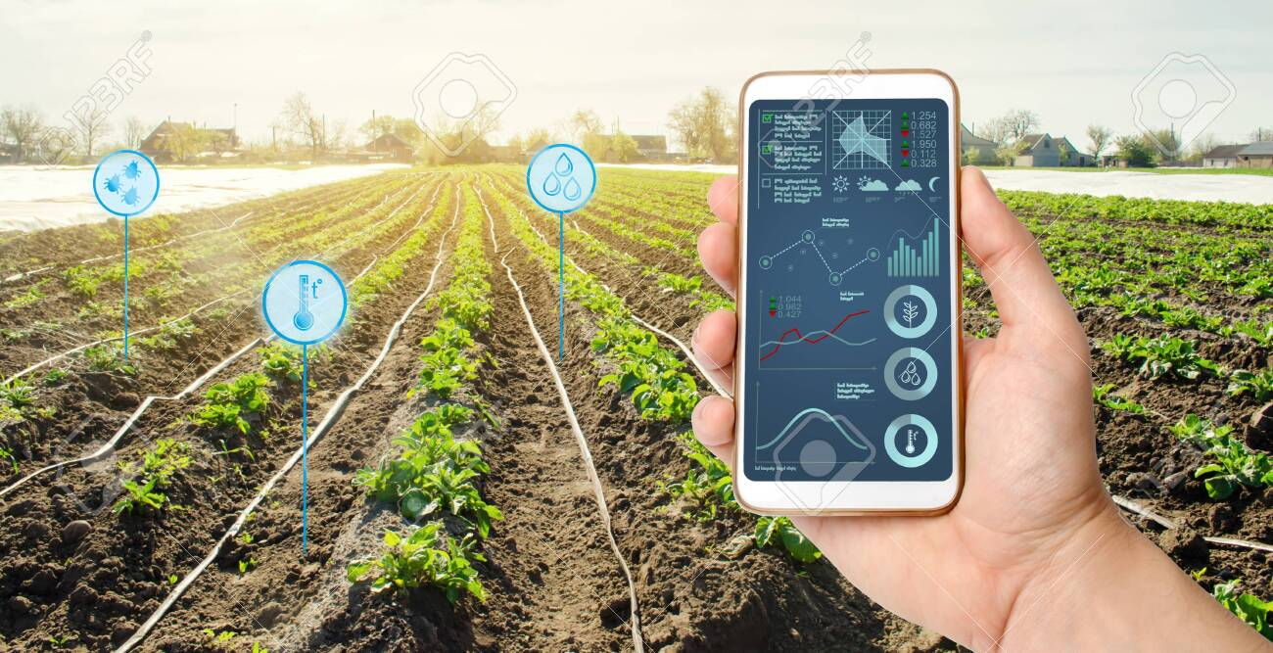

|  |
| --- |
| Project  proposal |
|  |
| Provide by : Nouf Alswuida |

* What is the framing question of your analysis, or the purpose of the model/system you plan to build?

When we build smart products in the field of the Internet of Things, we need a certain prediction to program the product to adapt to this prediction, meaning when I want to build smart solutions for farming in smart farms, I must have a forecast for the weather and rain that may fall at that time of the year Water consumption should be reduced from the usual percentage in the pump in order to avoid the excess water percentage on crops and plants, which may become adverse results on productivity. also Also, when smart farming, I will make a prediction of soil moisture and its quality for cultivation, and then operate the plowing automatically based on the moisture content in the soil according to the measurements of the soil sensor, which calculates and collects data and uploads it to the cloud.

* Who benefits from exploring this question or building this model/system?

Producer: IoT engineer.

Client: farmer , Agriculture companies.

Data Description:

* What dataset(s) do you plan to use, and how will you obtain the data?

I'm going to use the weather dataset & soil moisture dataset.

By searching the internet for the most suitable dataset that helps my goal.

* What is an individual sample/unit of analysis in this project?What characteristics/features do you expect to work with?

Temperature, humidity, rainfall, solar radiation, soil moisture, soil temperature.

* If modeling, what will you predict as your target?

Determine the days of the year when the temperature and humidity are appropriate,

and there is a high probability of rain. Determine the appropriate value of the soil that makes it suitable for plowing, cultivation and operation of smart devices.

Tools:

* How do you intend to meet the tools requirement of the project?

Anaconda Navigator – Jupyter.

* Are you planning in advance to need or use additional tools beyond those required?

In this time No.